Exercise 2: Implementing Dependency Injection

Scenario: In the library management application, you need to manage the dependencies between the BookService and BookRepository classes using Spring's IoC and DI.
Steps:
1. Modify the XML Configuration:
- Update applicationContext.xml to wire BookRepository into BookService.
2. Update the BookService Class:
- Ensure that BookService class has a setter method for BookRepository.
3. Test the Configuration:
- Run the LibraryManagementApplication main class to verify the dependency injection.

IMPLEMENTAION:
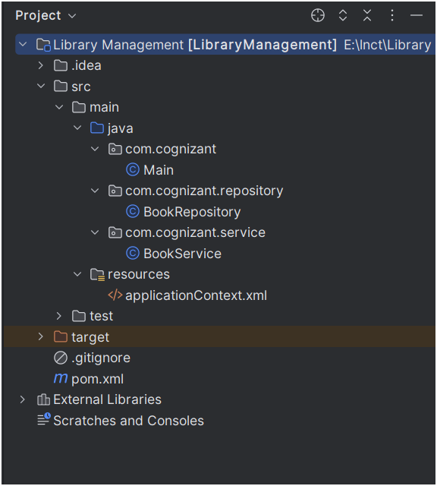
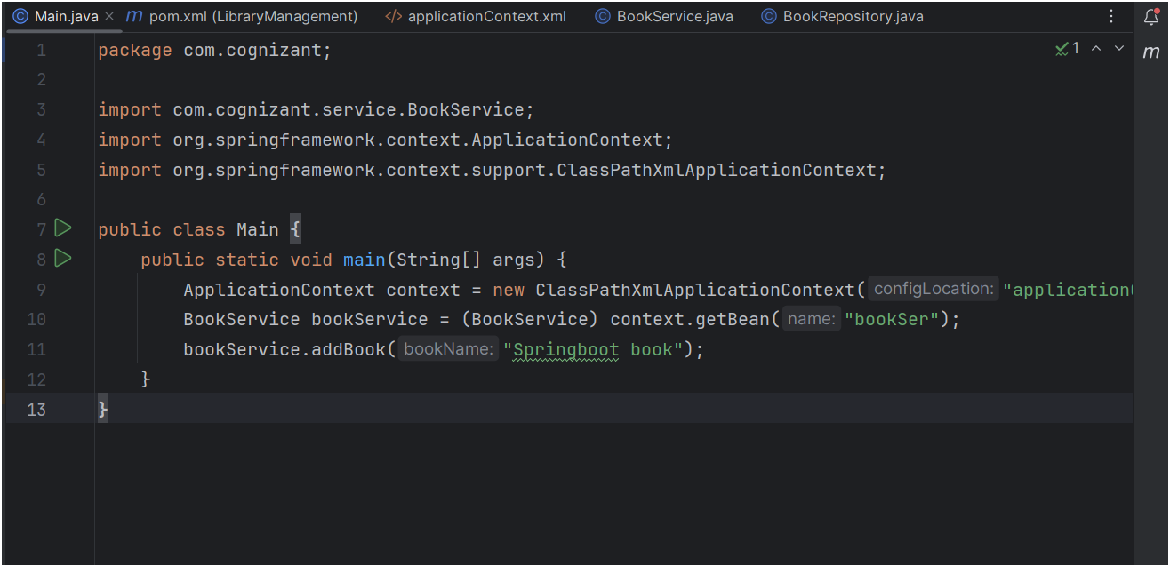
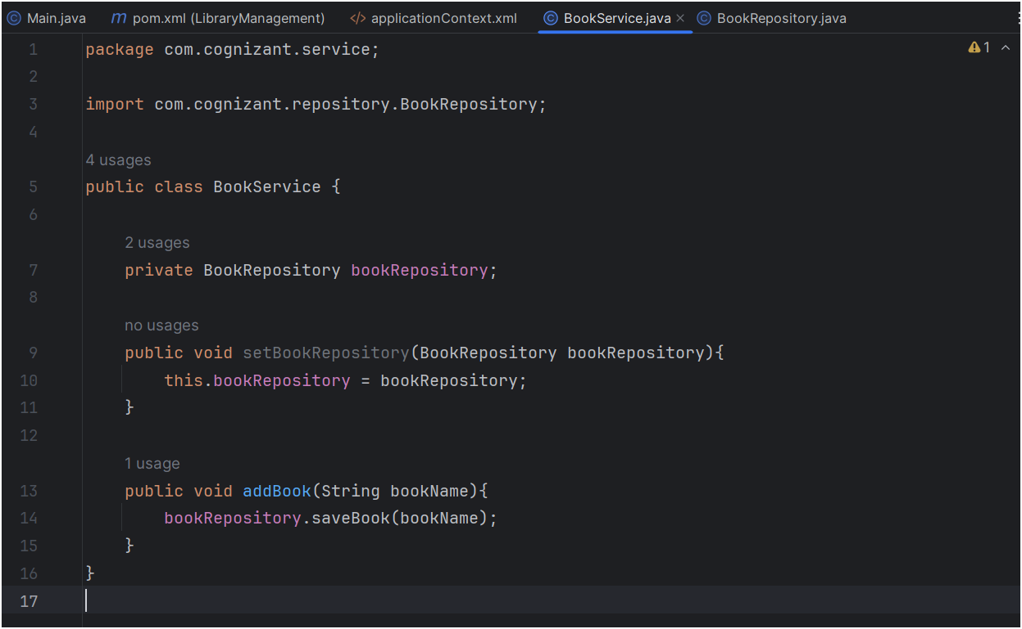

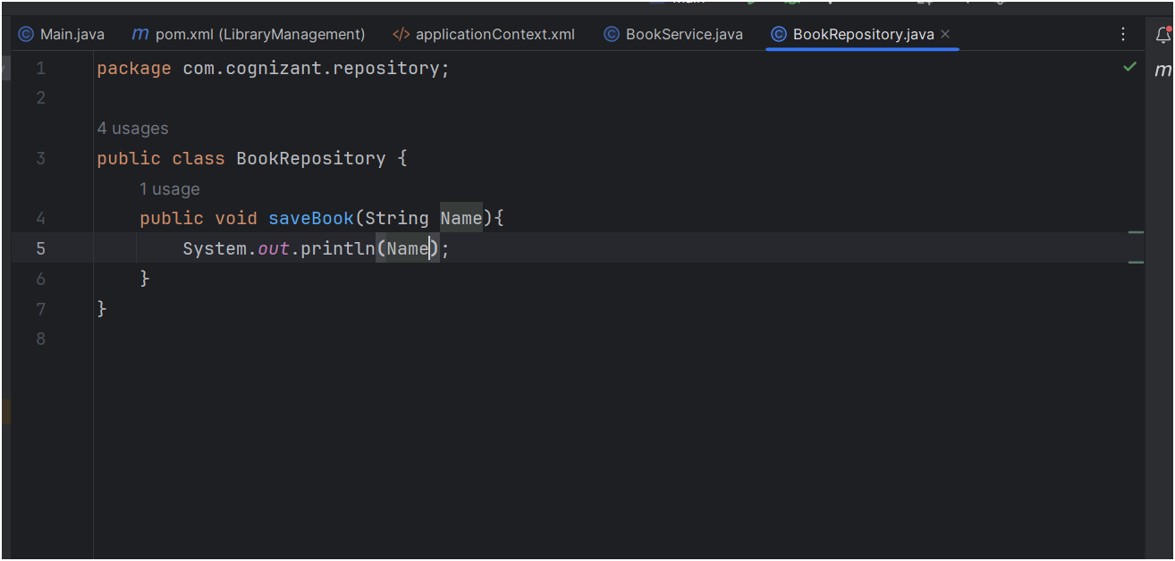
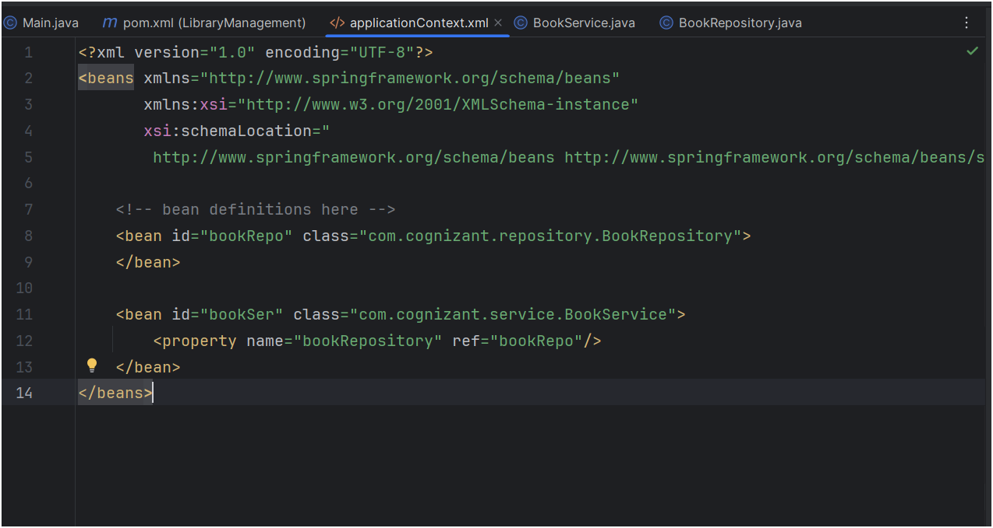
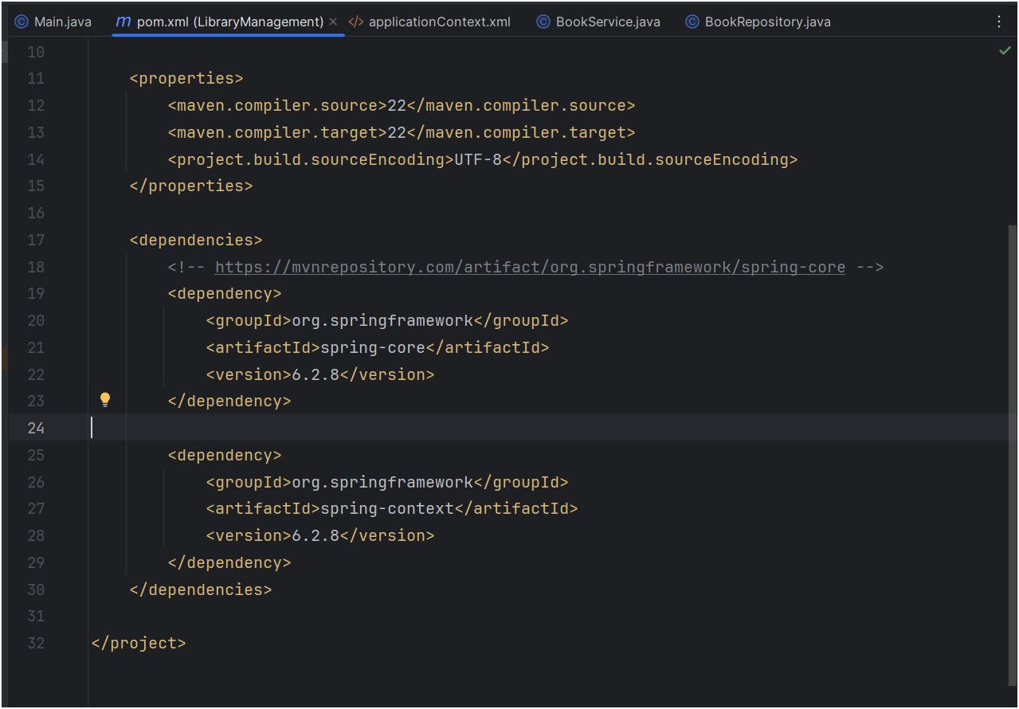
OUTPUT :
